**Соедини слово и схему, и вставь буквы:**

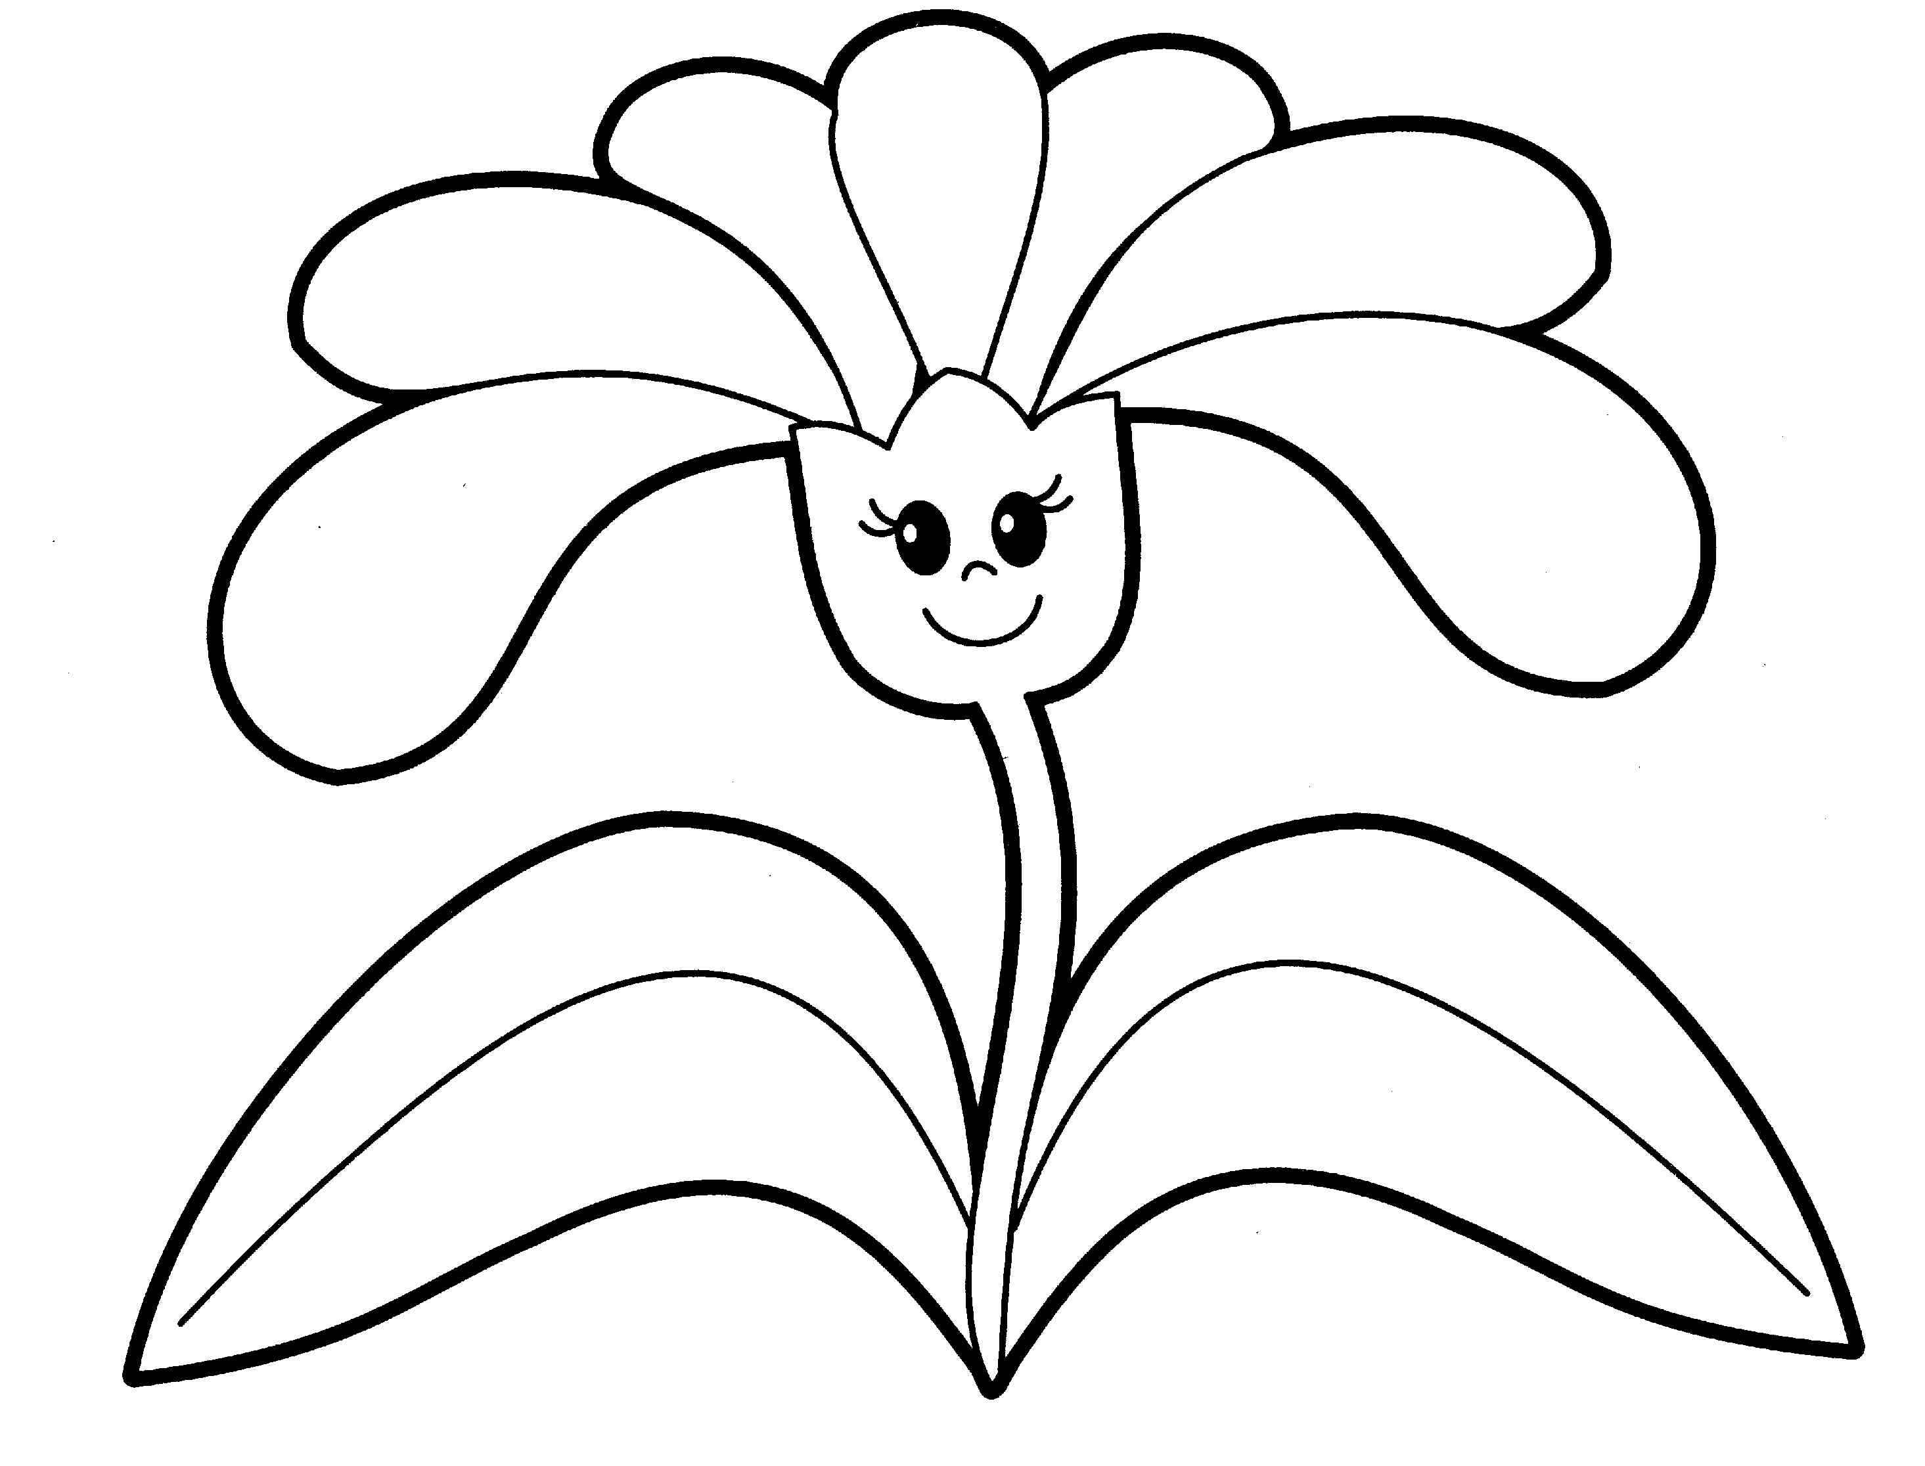

|  |  |  |  |  |  |  |  |
| --- | --- | --- | --- | --- | --- | --- | --- |
|  | а |  | е |  | и |  | а |

|  |  |  |  |  |  |
| --- | --- | --- | --- | --- | --- |
| **ц** | **в** | **е** | **т** | **о** | **к** |

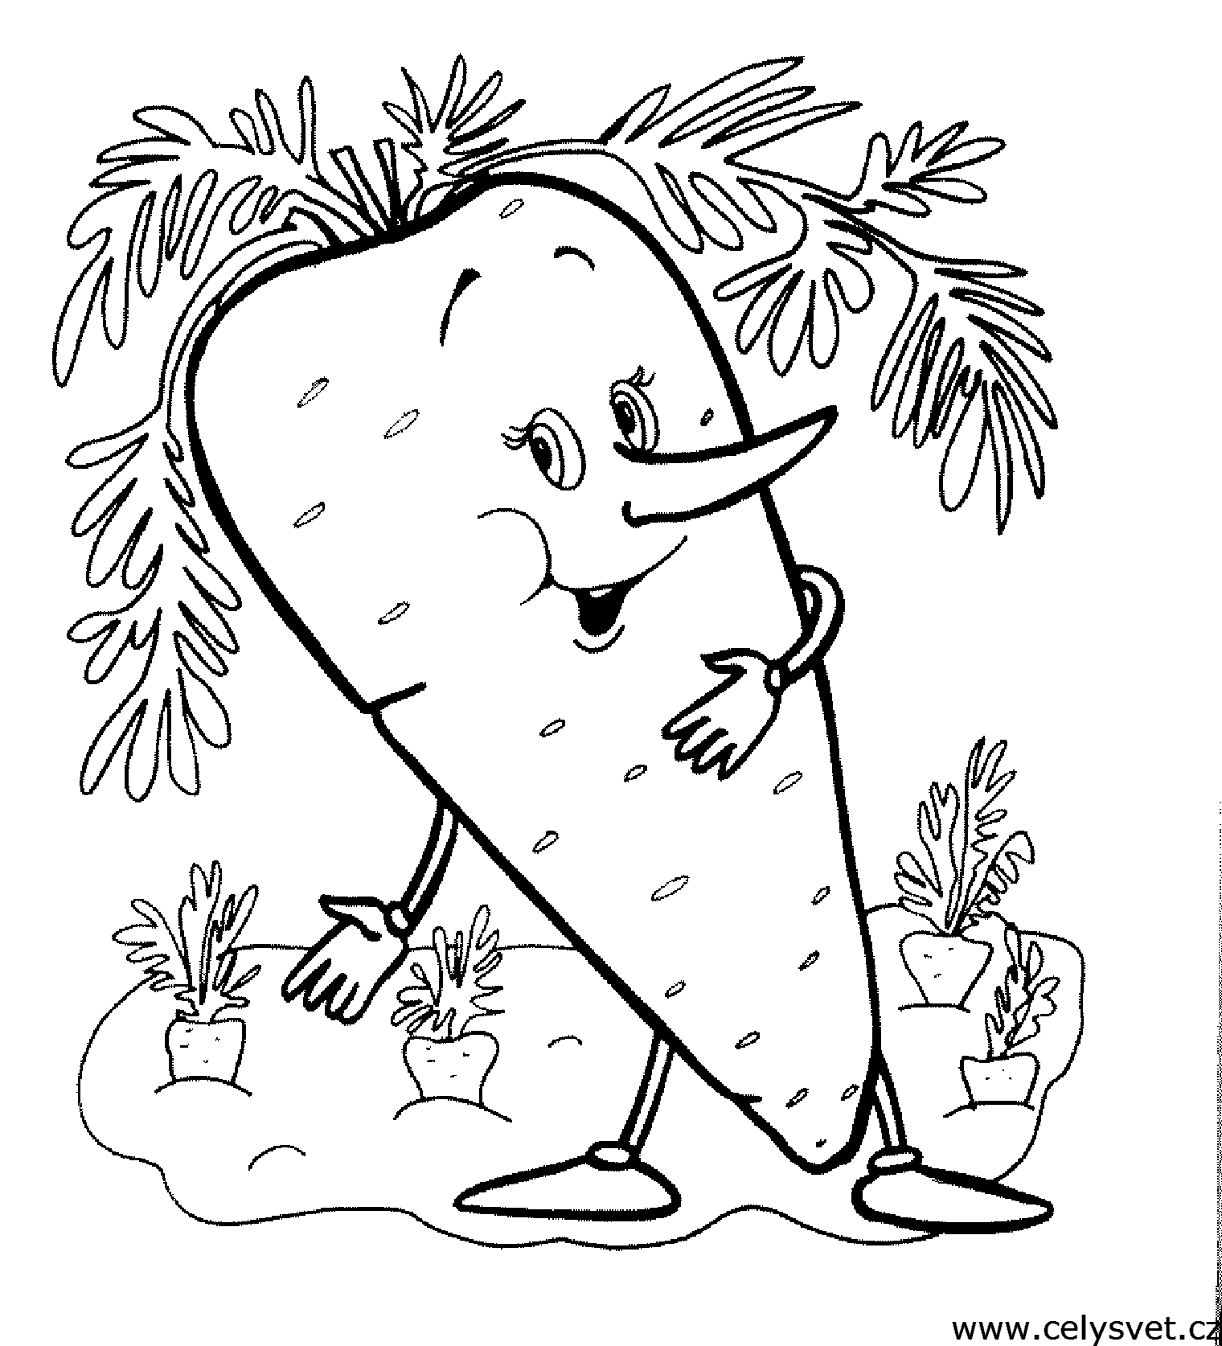 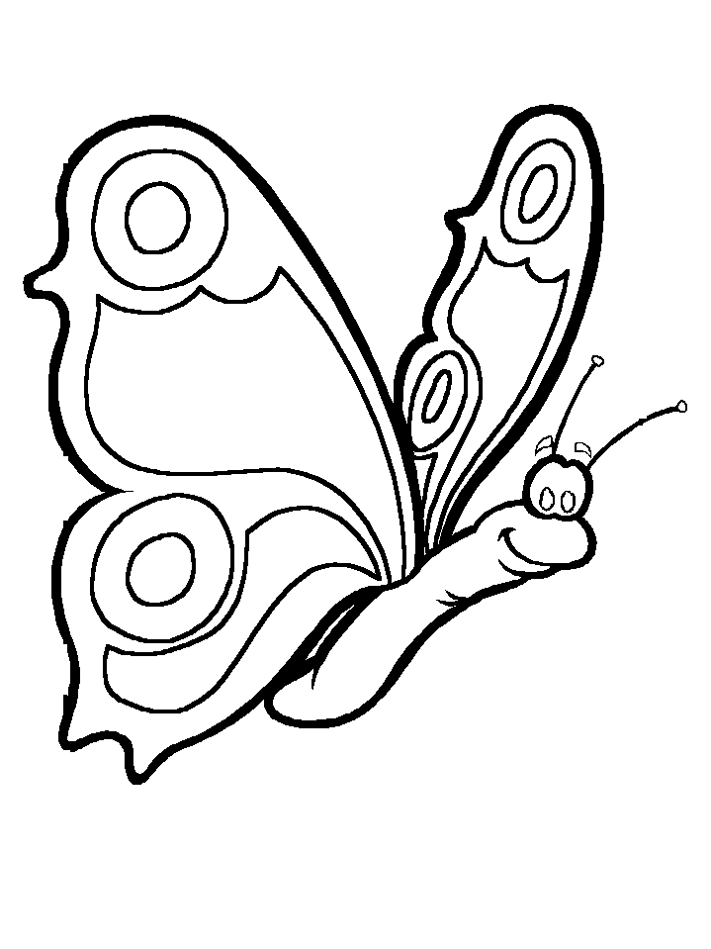

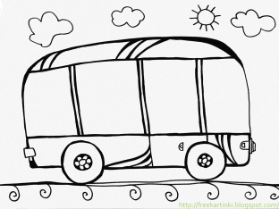 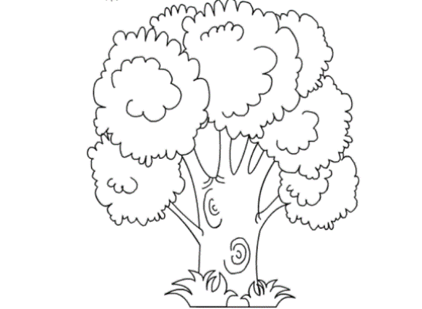 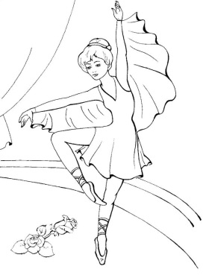

|  |  |  |  |  |  |
| --- | --- | --- | --- | --- | --- |
|  | е |  | е |  | о |

|  |  |  |  |  |  |  |
| --- | --- | --- | --- | --- | --- | --- |
|  | а |  | о |  |  | а |

|  |  |  |  |  |  |
| --- | --- | --- | --- | --- | --- |
|  | а |  | и |  | а |

|  |  |  |  |  |  |
| --- | --- | --- | --- | --- | --- |
|  | о |  | о |  |  |